Sunday 16th of May, 2021
Poderi Crisci welcomes
Petra Rijnbeek
A very jazzy sort of lunch.

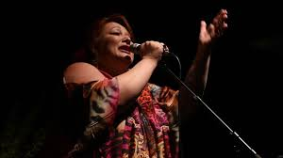

The highly acclaimed and very talented Petra Rijnbeek will be performing live at Poderi Crisci on the afternoon Sunday the 16th of May.
This will be a very intimate performance, available only to our dining guests on this date. You will enjoy our famous 6 course long lunch and be enchanted by the power and passion that Petra brings to Jazz.
The long lunch costs $105 per person, beverage charged on consumption.
Please email us here to book your seat now.

