Friday the 14th of May, 12.30-4.00pm.
Poderi Crisci invites you to
Lunch with Artist Barry Fenton
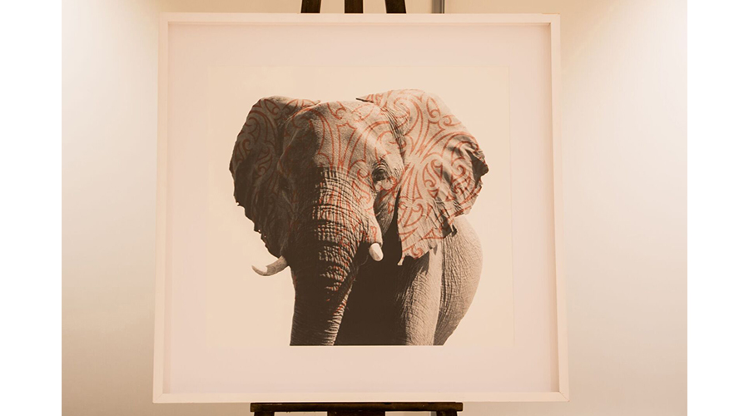

Barry Fenton, Waiheke Personality, philanthropist, artist and generally interesting bloke.
Barry will be displaying some of his works at Poderi Crisci as part of the 2021 Waiheke Wine and Food Festival.
You are invited to have a seat at the artists table on the afternoon of Friday the 14th of May. Barry will take you on a tour of his installations around the property over the course of lunch, offering you an insight into the workings of an artists mind and passion.
Pieces are available for purchase or commission. Barry and his Cavoodle Teddy are bis supporters of WISCA (Waiheke Island Shelter for Care of Animals), who benefit from all sales.
A traditional 6 course long lunch with a glass of Prosecco on arrival.
(Other beverages charged on consumption)
$105 per person.
Contact Poderi Crisci to get your tickets to this event.

